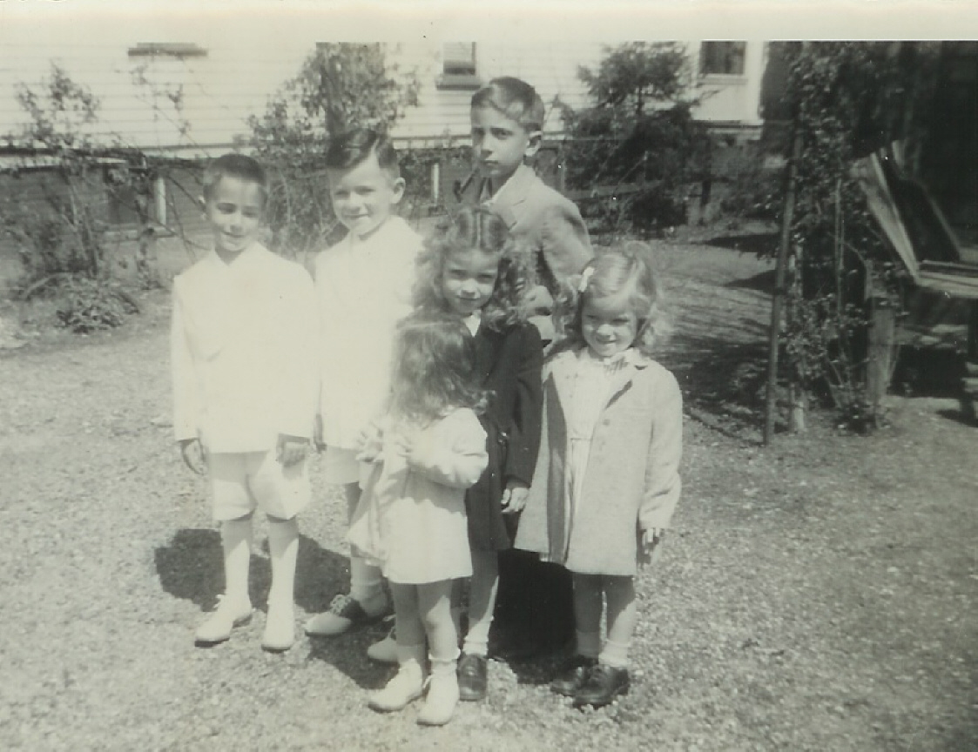

First Communion Picture
L to R : Bobby Longo, Michael Smith, John Longo, Smith Sisters
Orange, NJ, Late 1940’s

